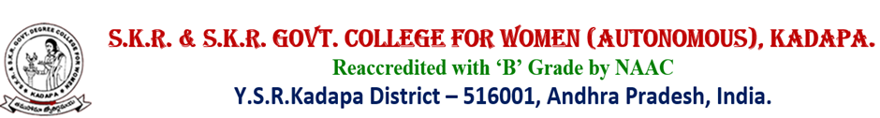
Alumni Association
2018-2019
Medical Camp-Health Check up
Report
31-1-2019
A medical camp in the college is conducted for the general health check up of the students under the auspices of Alumni Association on the 31st January,2019,from 5.00pm to 6:30pm in the college campurs, with the permission of the principal Dr.P.Subba Lakshumma
Dr.P.Jeevaprakasam,BHMS(Retired Professor of Homeopathy Philosophy) of Govt.Homeopathy College, Kadapa a senior Homeopathy Physician was kind enough to make general check up to the students.
Smt.S.Suseela Lecturer in Botany and Convener of Alumni Association organized the programme and introduced the physician to the students and mobilized them to undergo health check up.
About 70 students attended the camp and taken medical advice for improving their health condition.
Dr.P.Subba lakshumma,Principal, Smt.S.Suseela, Convener and the students felicitated the physician Dr.P.Jeevaprakasam on this occasion.
The physician after checking the health of the students advised several medical precautions and prescribed medicines
31-1-2019 Signature
